DBMS and RDBMS
What is DBMS?
- DBMS stands for Database Management System.
- It is software used to store, manage, and retrieve data efficiently.
- Data is stored in the form of files or tables.
- DBMS allows users to insert, update, delete, and view data.
- It supports single-user or small multi-user environments.
- Relationships between data are not mandatory.
- Data redundancy can be high.
- It provides basic security features.
- Examples include File System, XML-based databases.
- DBMS is suitable for small-scale applications.

What is RDBMS?
- RDBMS stands for Relational Database Management System.
- It stores data in the form of related tables (relations).
- Each table consists of rows and columns.
- It uses primary keys and foreign keys to maintain relationships.
- RDBMS follows relational database rules (Codd’s rules).
- It reduces data redundancy through normalization.
- It supports multi-user access with concurrency control.
- Provides strong security and data integrity.
- Uses SQL (Structured Query Language) for data operations.
- Examples include MySQL, Oracle, SQL Server, PostgreSQL.

Difference Between DBMS and RDBMS
Basis | DBMS | RDBMS
1. Full Form | Database Management System | Relational Database Management System
2. Data Storage | Files or tables | Related tables
3. Data Relationship | Not mandatory | Mandatory
4. Keys | No concept of primary/foreign keys | Uses primary and foreign keys
5. Data Redundancy | High | Low
6. Normalization | Not supported | Supported
7. User Support | Single or limited users | Multiple users
8. Data Integrity | Low | High
9. Security | Basic | Strong
10. Usage | Small applications | Large and complex applications
Question based on my Scenario
A customer named Gupta has been purchasing products from a supermarket for several years. One customer can make many purchases, and each purchase refers to a product.
1) How do we define this relationship?
2) Write the Entity Relationship
Answer:
1) ONE-TO-MANY (1 : N)
As,
- One customer (Gupta)
can make many purchases
- But each purchase belongs to only one customer
So, the relationship is:
Customer → Purchases
- 1 → Many

Example:
Gupta is one person
Over 5 years, he has bought:
Rice, Oil, Sugar, Vegetables, Many times
So:
- Gupta = 1
- Purchases = many

2) Entity Relationship:

Entity 1: CUSTOMER
This represents a person like Gupta who has been purchasing for 5 years.
Customer Entity
Customer

Customer_ID (PK)
Name
Phone
Address
Customer_Since

Entity 2: PRODUCT
This represents items that can be purchased.
Product Entity
Product

Product_ID
Product_Name
Price
Category

Entity 3: SALES / PURCHASE
This entity stores every purchase made by a customer.
Sales Entity
Sales

Sale_ID
Customer_ID (FK)
Product_ID (FK)
Quantity
Purchase_Date

Entity Relationships (ER Explanation)
Customer → Sales
- Relationship: ONE-TO-MANY (1 : N)
- One customer (Gupta) can have many sales
- Each sale belongs to only one customer
Customer (1) ───────< Sales (Many)

Product → Sales
- Relationship: ONE-TO-MANY (1 : N)
- One product can be sold many times
- Each sale refers to one product
Product (1) ───────< Sales (Many)

Customer ↔ Product (Indirect Relationship)

Customer and Product have a MANY-TO-MANY relationship in real life:
- One customer buys many products
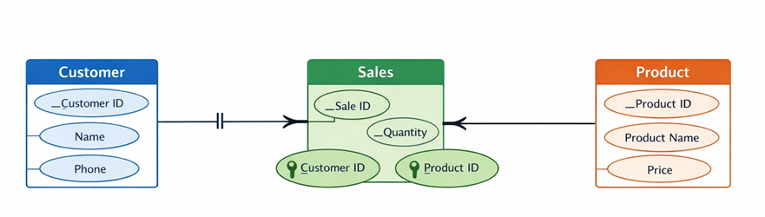
- One product is bought by many customers

